WBAT v5.18 Upgrade Supplement
Updates – Web/browser interface only

Employee Reporting – Submitter forms get a new look. The User Interface (UI) has been updated, and submitter forms have the following major changes:
- Top-anchored information bar provides “always-available” access to form icons, buttons, menu options and submission status
  - New Icons
    -  Collapse All – Collapses all banners/sections on the form. Changes to Expand All when clicked.
    -  Expand All – Expands all banners/sections on the form. Changes to Collapse All when clicked.
    -  Save and Continue – Allows submitter to save current progress and continue without exiting the form.
    -  Save and Complete Later – Allows submitter to save their current progress, exit the form and open it later for continued progress or to complete the form.
    -  ? – This is the required fields icon. On hover (mouse-over) it displays the required fields/items remaining (the hover display is in a separate dialog box in the top-center of the screen).
    - Hamburger Menu – allows submitter to execute the Home and Back functions from within the form. Home leaves the form (without saving any information entered) and takes the submitter to their Home screen, while Back leaves the form (without saving any information entered) and takes the submitter to the previous page (the previous page may be the same as the Home page)
  - Buttons
    -  Submit – clicking the green submit button submits a completed report. A subdued (grayed-out) submit button indicates there are required fields/items that must be completed. On hover (mouse-over) the subdued submit button displays the required fields/items remaining (the hover display is in a separate dialog box in the top-center of the screen).
    -  Back – clicking Back leaves the form (without saving any information entered) and takes the submitter to the previous page.
- Section fields/attributes are now dynamically provided in two columns
- Employee Information Section eliminated – Employee information is no longer included on the submission forms. When necessary, users should update their profile information separately in the Profile option (found on the Home screen under the “Hello, user first name”)
- Special Sections with potentially iterative content (Other Employees, JASC Event/JASC Failure, Hazmat Event Information) are now dynamic. The submitter clicks the symbol to add an item, or the symbol to remove an item.

Safety Assurance – Audits, Evaluations and Inspections all received the new UI update in the last major release. In this release, launching a Finding or Corrective Action from a checklist within Audits, Evaluations or Inspections updates these interactive forms as well. Only the look has been updated. All other functionality within Safety Assurance remains unchanged.
- Finding – Clicking, Add Finding, from a checklist item launches the Finding dialog box with the new UI applied
- Clicking, Add Corrective Action, from the added Finding of a checklist item launches the Corrective Action dialog box with the new UI applied.

Safety Risk Management – New SRA gets a new look. The User Interface (UI) has been updated, and the new SRA form has the following major changes:
- Top-anchored information bar provides “always-available” access to form icons, buttons, menu options and submission status
  - New Icons
    - Collapse All – Collapses all banners/sections on the form. Changes to Expand All when clicked.
    - Expand All – Expands all banners/sections on the form. Changes to Collapse All when clicked.
    - ? – The required fields icon. On hover (mouse-over) it displays the required fields/items remaining (the hover display is in a separate dialog box in the top-center of the screen).
    - Hamburger Menu – allows submitter to execute the Home and Back functions from within the form. Home leaves the form (without saving any information entered) and takes the submitter to their Home screen, while Back leaves the form (without saving any information entered) and takes the submitter to the previous page (for some users, the previous page may be the same as the Home page)
  - Buttons
    - Submit – clicking the green submit button submits a completed form. A subdued (grayed-out) submit button indicates there are required fields/items that need to be completed. On hover (mouse-over) the subdued submit button displays the required fields/items remaining to be completed (the hover display is in a separate dialog box in the top-center of the screen).
    - Back – clicking Back leaves the form (without saving any information entered) and takes the user to the previous page.
- Section fields/attributes are now dynamically provided in two columns
- Button options eliminated – In the enhanced UI, buttons for, “No Hazards – Complete SRA”, and “Add Hazards – Continue SRA”, are no longer provided. To process a completed SRA with or without hazards, click Submit, and then open the SRA and use the Action Menu to either add hazards (then risks and risk controls) or process/complete the SRA without hazards.

Operational Data
Submission Form Editor - For those with the access authority and the correct privileges, the form editor is completely transformed. It has a new look with the enhanced UI and all new functionality that includes:
- Anchored form controls
  - Top-anchored information bar with form title includes:
    -  Undo – This icon holds all keystrokes (per session) and allows users to undo them in order
    - Collapse All – Collapses all banners/sections on the form. Changes to Expand All when clicked.
    - Expand All – Expands all banners/sections on the form. Changes to Collapse All when clicked.
    -  Save – After form edits, Save must be clicked for changes to be applied.
    - Hamburger Menu – allows submitter to execute the Home, Back and Settings functions from within the form.
      - Home - leaves the form (without saving any information entered) and takes the submitter to their Home screen.
      - Back - leaves the form (without saving any information entered) and takes the submitter to the previous page (for some users, the previous page may be the same as the Home page)
      - Settings – opens a User Settings screen. Users may choose from 3 display name settings, “Submission Form Editor Label Mode”. This applies to the aspect | category | attribute names displayed in the form editor session. Select the desired setting and click the Back option in the hamburger menu.
        - Default Taxonomy Label – this is the default setting and displays the attribute Label.
        - Attribute Name – selecting this setting displays the attribute Name.
        - Custom Taxonomy Label – selecting this setting displays the attribute Custom Label, if added. If there is no Custom Label this setting displays the attribute Label.
- Anchored form elements
  - Left-anchored element selection pane
    - Drag and drop form elements from, Add Item, into the form body
      - Add Banners, Sections and Fields.
        - A Banner must be dropped first, then a Section below the Banner, then Field(s) below the Section
          - A Banner may be dropped between, above or below other banners, but not between a Banner and a Section
          - A Section may be dropped between, above or below other sections, but not between a Section and a Field
          - A Field may be dropped between, above or below other fields, but not below a Banner or a Special Section (premade)
      - Add Special Sections (premade) to the form body. These can be placed below a Banner or Section but not between a Section and a Field
        - Attachment – gives submitters the ability to add Attachments
        - Flight Select – If providing flight schedule information to WBAT, gives submitters the ability to select their flight information from a list of provided flights
        - Hazmat Event Information – gives submitters the ability to provide detailed information for hazardous item issues
        - JASC Event/JASC Failure – gives submitters the ability to add JASC (Joint Aircraft System/Component) codes to define events or failures of aircraft parts or systems. Only one JASC section can be on a form, Event or Failure.
        - Other Employees – gives submitters the ability to identify other employees involved in the event being reported.
- Anchored attribute view
  - Bottom-anchored attribute view, Attribute:
    - On hover (mouse-over) of any Field element, the taxonomy attribute Name is displayed with corresponding aspect and category names, aspect | category | attribute






- Form editor body functions
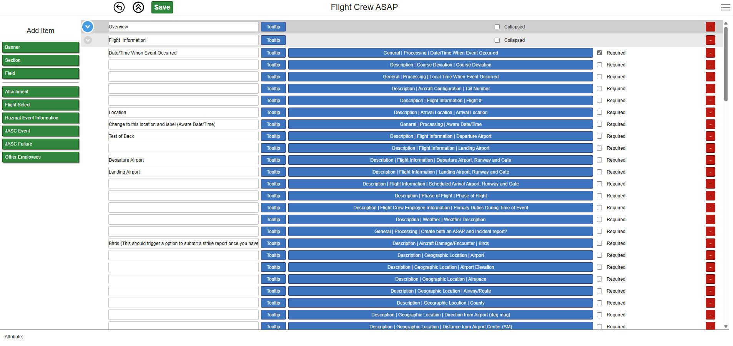
  - 1-Collapse/Expand – for added Banner and Section elements, the far-left column allows for collapsing or expanding the elements in that Banner or Section.
  - 2-Element Label – each form element allows for the label to be added/modified.
    - Banner and Section come with a default labels (Banner or Section respectively)
    - Field is blank by default. A blank Field label displays the taxonomy Label. If a Custom Label is provided in the taxonomy, the Custom Label will be the form Field label. If a form label is provided in the element label text box, that label will be the Field form label.
  - 3-Tooltip – clicking the Tooltip button opens the Tooltip dialog box.
    - Banner and Section – allows the addition of separate textual information below the Banner or Section element label.
      - Support for HTML is provided. Add HTML tags in the Tooltip text to provide text effects, e.g., color, bold, underline, line feed/carriage return, etc.
    - Field – allows the addition of separate textual information displayed in a hover (mouse-over) of the Field label. Does NOT support HTML tags
  - 4-Field information - blue bars provide the Field name information (as determined by the form editor Settings), aspect | category | attribute.
    - Adding a new Field
      - Drag and drop Field anywhere under an existing Section
      - The information bar displays, | |
      - Clicking the bar provides a Field selection dialog box
      - Enter the Aspect, Category and Attribute name and click OK
      - The new Field is added and the attribute name is displayed in the Field information bar
    - Adding a new combo-box (dropdown) Field
      - Drag and drop Field anywhere under an existing Section
      - The information bar displays, | |
      - Clicking the bar provides a Field selection dialog box
      - Enter the Aspect, Category and Attribute name
      - The Manage Values button turns blue
      - Clicking the Manage Values button opens the Mange Values dialog box and allows adding, deleting or modifying values for the attribute.
      - Make value changes and Click OK
      - The Field selection dialog box reappears, click OK
      - The new Field is added, and the attribute name is displayed in the Field information bar
NOTE: Manage Values can still be accomplished from the Operational Data module under Taxonomy
  - 5-Collapsed/Required checkboxes
    - Banner and Section – click the Collapsed checkbox to have the Banner or Section begin collapsed in the submitter form
    - Field – click the Required checkbox to mark the Field as required on the submitter form
NOTE: Required fields will prevent the form from being submitted until all required items are completed
  - 6-Element removal/deletion
    - Click the symbol on the far-right to remove the element from the editor and delete it from the submitter form

Taxonomy - For those with the access authority and correct privileges, taxonomy changes now require a manual process to rebuild the UI cache so changes are available within the form editor.
- Taxonomy – UI Cache Is Up To Date
  - This is the message displayed in the header of the Taxonomy section of Operational Data indicating that no changes have been made to the taxonomy
- Taxonomy – UI Cache Is Dirty
  - This is the message displayed in the header of the Taxonomy section of Operational Data indicating changes have been made to the taxonomy requiring the UI cache to be rebuilt
  - This occurs when:
    - An Attribute’s “Enabled:” status has changed
      - Manage Attributes - individually within each attribute
      - Manage Categories - All attributes within a category
    - A Custom Label has been added, modified or removed for an Attribute or Category
  - Click the Rebuild UI Cache option to run the rebuild.
    - The Rebuild Taxonomy UI Cache dialog box opens
    - Click OK
    - The Confirmation dialog box opens
    - Click OK
    - The rebuild process may take several seconds to a few minutes to complete.
    - When the Rebuild UI Cache finishes, UI Cache Is Up To Date, will be displayed in the Taxonomy section header.

