Web-Based Application Tool (WBAT)
Submitter Guide

23 Jun 16

Standard Documentation Conventions iv
1. Using Web-Based Application Tool (WBAT) to Submit a Report 1
Getting Help/Troubleshooting 1
WBAT Screen Layout 2
Function of WBAT Icons 3
WBAT Tasking Screens Icons 3
Report and Search Screens Icons 5
WBAT Date Selector Icons 6
WBAT Time Selector Icons 7
2. Getting Started 7
Logging into WBAT 8
Accessing Your WBAT Home Page 8
Accessing the Log In Screen 8
Logging In 9
Updating Your Profile 10
Accessing the Edit Contact Information Screen 10
Editing Your Contact Information 11
Changing Your Password 12
Accessing the Edit Password Screen 12
Specifying a New Password 12
Logging Out of WBAT 13
3. Working with Reports 13
Adding a New Report 13
Understanding the New Report Screen Design 15
Understanding Tooltips 15
Understanding Report Narratives 15
Understanding NASA ASRS Data Sharing 16
Saving Your Report 16
Saving and Completing Your Report Later 17
Saving and Continuing Your Report 17
Submitting Your Report 18
Cancelling Your Report 18
Verifying Your Contact Information 18
Confirming Your Contact Information 18
Updating Your Contact Information 18
Completing Your Report 19
Adding an Attachment 19
Adding Multiple Attachments 20
Printing Your Submission Receipt 20
Creating a Fatigue Report from Your Submission Receipt 20
Searching Your Reports 20
Displaying the Search Reports Screen 20
Accessing the Search Reports Screen from the Report Summary 21
Specifying Search Criteria 22
Selecting a Report 23
Finishing Your Incomplete Report 23
Selecting an Incomplete Report 24
Finishing an Incomplete Report 24
Finishing a Hotline Report 24
Selecting a Hotline Report 26
Finishing a Hotline Report 26
Viewing and Modifying Reports or Printing Submission Receipts and Reports 26
Selecting a Report to View 28
Understanding the Submitted Report Screen 28
Modifying Your Modified or Open Report 29
Submitting Your ASAP or Incident Report to ASRS 29
Printing Your Modified, Open, or Closed Report 29
4. Understanding WBAT Safety Notices 30
5. Performing a System Search 30
6. Using the Messaging System 31
Sending Messages 31
Specifying Message Recipients 32
Attaching a Report to a Message 32
Searching for a Message 33
Viewing Messages 34
Replying to Message Requests 35
Appendix A. Key Terms 37

Figure 1–1. WBAT Screen Layout 2
Figure 1–2. WBAT Report Screen Icons 5
Figure 1–3. WBAT Date Selector Icons 6
Figure 1–4. WBAT Time Selector Icons 7
Figure 2–1. Sample WBAT Home Page 8
Figure 2–2. Log In Screen 9
Figure 2–3. Sample My Reports Screen 9
Figure 2–4. Sample My Reports Screen Showing Report Summary Links 10
Figure 2–5. Profile Link 11
Figure 2–6. Edit Contact Information Screen 11
Figure 2–7. Password Link 12
Figure 2–8. Edit Password Screen 12
Figure 3–1. Add Report Icon 13
Figure 3–2. Sample New Report Screen 14
Figure 3–3. Tooltip 15
Figure 3–4. Update Link 16
Figure 3–5. ASRS Data Sharing Field 16
Figure 3–6. Save Buttons 17
Figure 3–7. Finish an Incomplete Report Link 17
Figure 3–8. Employee Information Subsection of the New Report Screen 18
Figure 3–9. Choose File Button 19
Figure 3–10. Report Search Screen 21
Figure 3–11. Open Report Summary Button 21
Figure 3–12. Search Reports Link 22
Figure 3–13. Reports Screen 22
Figure 3–14. Finish an Incomplete Report Link 23
Figure 3–15. Reports (Incomplete) Screen 24
Figure 3–16. Finish a Hotline Report Link 25
Figure 3–17. Reports (Hotline) Screen 25
Figure 3–18. Finish a Hotline Report Link 27
Figure 3–19. Reports (Modified) Screen 27
Figure 3–20. Submitted Report Screen 28
Figure 3–21. Update Link 29
Figure 4–1. WBAT Safety Notice Section 30
Figure 5–1. Category Drop-down List and Text Box 31
Figure 6–1. Send a Message Link 31
Figure 6–2. New Message Screen 32
Figure 6–3. Sending a Message from a Report 33
Figure 6–4. Search Received Messages and Search Sent Messages Links 34
Figure 6–5. Links for Viewing Messages of Various Statuses 35
Figure 6–6. Replies Requested by You Link 36

Table I–1. Standard Documentation Conventions iv
Table 1–1. WBAT Screen Layout 2
Table 1–2. WBAT Screen Icons 3
Table 1–3. WBAT Report Screen Icons 6
Table 1–4. WBAT Date Selector Icons 6
Table 1–5. WBAT Time Selector Icons 7
Table A–1. Key Terms 37

Standard Documentation Conventions
The following formatting conventions are used in this document and for certain screen element (e.g., field) labels:
Table I–1. Standard Documentation Conventions
Format | Description
Red | Required
Light blue | Highly recommended
Dark blue | Button
Dark blue underline | Link
Bold | Standard screen element label or expected user input
Italics-underline | Emphasis
Italics | Cross-reference to another section (e.g., see Getting Help/Troubleshooting)
Black underline | Cross-reference to different document (e.g., refer to the UTRS Safety Program Guide)
Blue underline | Unvisited email address
Plum underline | Visited email address
<Bracketed italics-underline> | Descriptive variable that is completely replaced (including brackets) with applicable user-defined text (e.g., where <userid> is your log in user name)
“Quotation marks” | Screen or message text

Using Web-Based Application Tool (WBAT) to Submit a Report
This guide describes how to complete and submit an online form (also referred to as a report) in the Web-Based Application Tool (WBAT) for an observed, discovered, or potential safety issue, incident, or concern, subsequently referred to as issue (see Working with Reports). Information about other key WBAT features includes:
- Safety notices–View short informational messages from your primary WBAT screen (see Understanding WBAT Safety Notices).
- System search–Find system information based on your specified search criteria (see Performing a System Search).
- Messaging–Send, search, and view messages created in WBAT (see Using the Messaging System).

- WBAT supports confidential and secure data sharing with NASA’s Aviation Safety Reporting System (ASRS). If your company participates in data sharing with ASRS, your original ASAP and/or incident reports can be transmitted to ASRS upon report submission either automatically or optionally (see Understanding NASA ASRS Data Sharing).
- See Appendix A: Key Terms for definitions of other WBAT-related terms and concepts.

Getting Help/Troubleshooting
If you have any questions or issues, contact your company’s help desk.

WBAT Screen Layout
The WBAT screen that follows consists of the components listed in Table 1–2 (left to right, top to top to bottom, with the circled numbers in the figure corresponding to the Key column). The components displayed on your work screen will vary and includes those appropriate for your task and privileges.
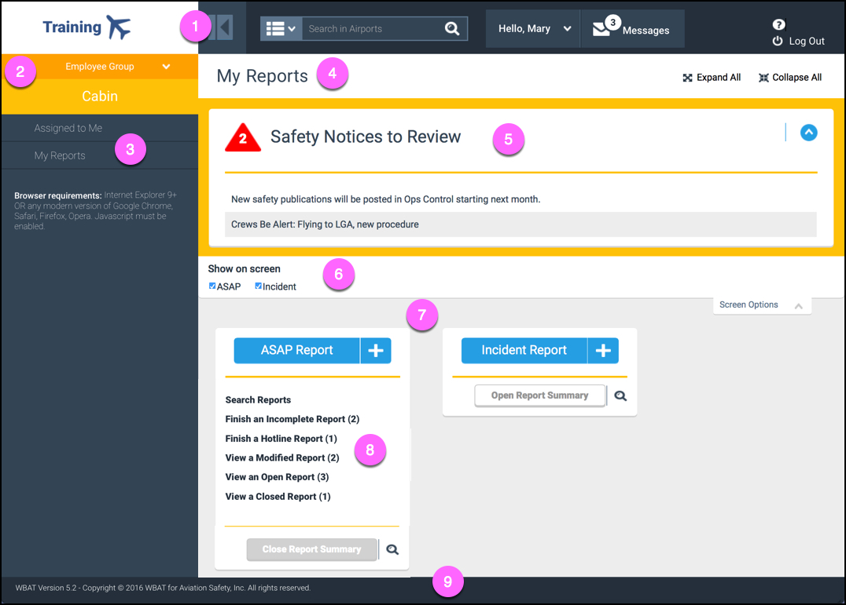
Figure 1–1. WBAT Screen Layout

Table 1–2. WBAT Screen Layout
Key | Name | Description
 | Header Bar | Contains standard components that let you perform such actions as searching, accessing your profile, and messaging.
 | Side Bar | Contains components that let you select your employee group (if you are assigned to multiple employee groups) and navigate to other screens to perform your tasking.
 | Side Bar Navigation Link | Displays information in the Workspace for the designated employee group.
 | Title Bar | Indicates the title of the screen selected in the side bar navigation and may include components to perform specific actions tailored for your tasking.
 | Action Bar | Expands/collapses to show/hide components tailored for your tasking such as buttons to perform specific actions or safety notices (i.e., short informational messages) associated with your employee group.
 | Screen Options Bar | Expands/collapses to show/hide one or more Section check boxes (depending upon your privileges). A check mark indicates the Section appears on your Workspace.
 | Workspace | Contains components, such as one or more Sections, tailored for your tasking.
 | Section | Contains the components that let you submit new reports and manage your previously submitted reports within a report type.
 | Footer Bar | Contains general information, including WBAT version number.

Function of WBAT Icons

WBAT Tasking Screens Icons
The following icons are used on the various WBAT tasking screens (see Figure 1–1):

“Hover” refers to moving the cursor over the icon.
Table 1–3. WBAT Screen Icons
Icon | Name | Description
 | Add Report | Displays the New Report screen so you can create a new safety report.
 | Back | Displays the previous screen.
 | Back | Displays the previous screen.
 | Category Search | Performs a search based on specified search criteria in the Category drop-down list and text box.
 | Drop-down List | Shows a list of items from which you make a selection.
< | Expand (Side Bar Navigation) | Shows the subitems for the current item in the Side Bar Navigation.
∨ | Collapse (Side Bar Navigation) | Hides the subitems for the current item in the Side Bar Navigation.
 | Expand (Side Bar) | Shows the Side Bar.
 | Collapse (Side Bar) | Hides the Side Bar.
∨ | Expand (Workspace) | Shows the details or subitems for the current item.
∧ | Collapse (Workspace) | Hides the details or subitems for the current item in the Workspace.
 | Expand All | Shows all details or subitems.
 | Collapse All | Hides all details or subitems.
 | Home | Displays the previous screen.
 | Help | Displays a pop-up window of support contact information when the cursor hovers over the icon.
 | Log Out | Logs you out of WBAT.
 | Message Counter | Indicates the number of unread messages
 | Messages | Represents the Messaging system.
 | Safety Notices Counter | Indicates the number of safety notices for the designated employee group.
 | Search | Displays the Report Search screen in which you specify criteria to search for reports.

Report and Search Screens Icons
The icons listed in Table 1–4 are used on the various report and search screens:
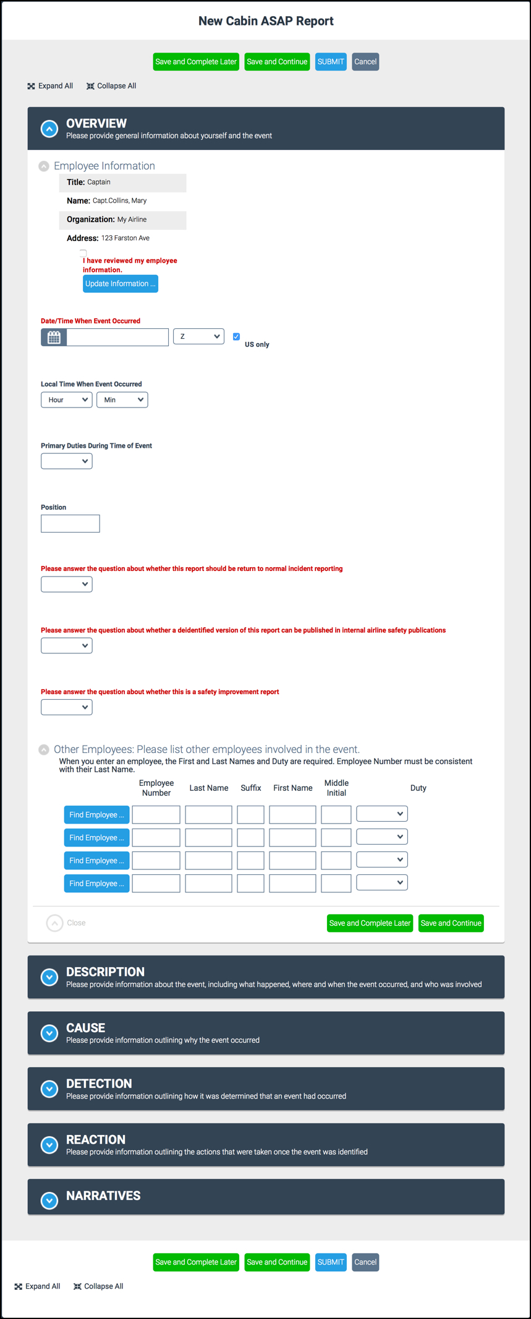
Figure 1–2. WBAT Report Screen Icons

Table 1–4. WBAT Report Screen Icons
Icon | Name | Description
 | More | Displays one or more screens to specify the information for the associated text box.
 | Date/Time | Displays a date selector (i.e., calendar) to specify a date, as well as the Time icon to display the time selector.
 | Search | Displays a screen in which you specify search criteria.
 | Close | Closes the report section.

WBAT Date Selector Icons
The following icons are used on the date selector:
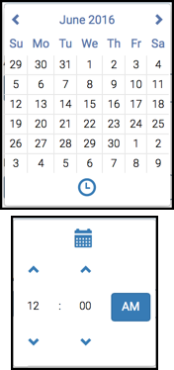
Figure 1–3. WBAT Date Selector Icons

Table 1–5. WBAT Date Selector Icons
Icon | Name | Description
 | Previous Month | Displays the previous month.
 | Select Month | Displays all months to select one.
 | Select Year | Displays a range of years to select one.
 | Next Month | Displays the next month.
 | Time | Displays the time selector to specify a time, as well as the Select Date icon to redisplay the date selector.

WBAT Time Selector Icons
The following icons are used on the time selector:
Figure 1–4. WBAT Time Selector Icons

Table 1–6. WBAT Time Selector Icons
Icon | Name | Description
 | Select Date | Redisplays the date selector to specify a date, as well as the Time icon to redisplay the time selector.
 | Increment Hour  Increment Minute | Increases, by 1, the currently specified hour or minute.
 | Pick Hour | Displays possible hours (default: 12).
 | Pick Minute | Displays possible minutes (default: 00; by fives).
 | Decrement Hour | Decreases, by 1, the currently specified hour.
 | Decrement Minute | Decreases, by 1, the currently specified minute.
 | Time of Day | Indicates automatically the time of day based on the time you specify.

Getting Started
This section provides instructions for getting started using WBAT, including:
- Logging into WBAT
- Updating Your Profile
- Changing Your Password
- Logging Out of WBAT

Logging into WBAT

Accessing Your WBAT Home Page
In your web browser, access the URL for WBAT (typically in the format: companyname-safety.wbat.org, where companyname is the unique identifier for your WBAT implementation). Your WBAT home page appears, which may be customized for your particular safety program.
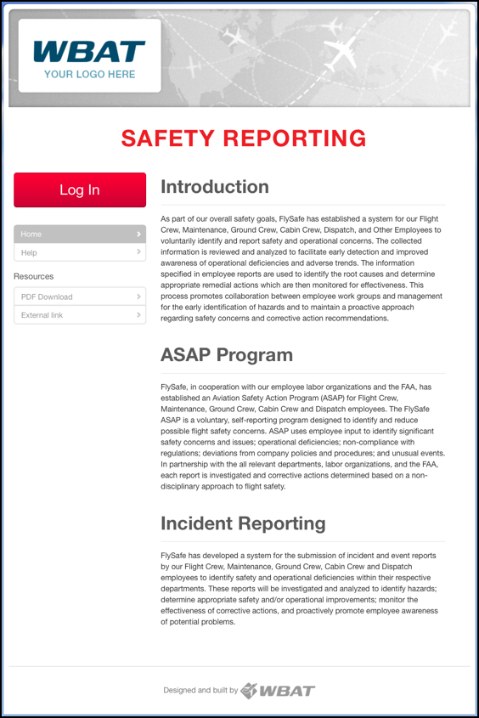
Figure 2–5. Sample WBAT Home Page

Accessing the Log In Screen
Select Log In. The Log In screen appears.
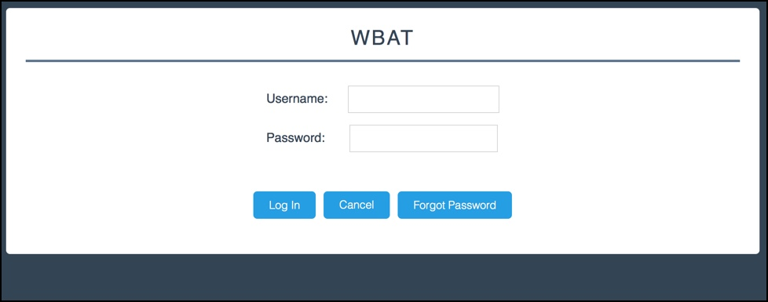
Figure 2–6. Log In Screen

Logging In
Specify your case-sensitive username and password, and then click Log In. The My Reports screen appears. This screen’s Workspace includes one or more report type Sections, depending upon your privileges. A report type Section includes an Add Report icon as well as the Open Report Summary button and Search icon. Additionally, if your company supports posting of documents (by employee group) for Submitters, a Communications Section appears, letting you access these documents, such as newsletters.
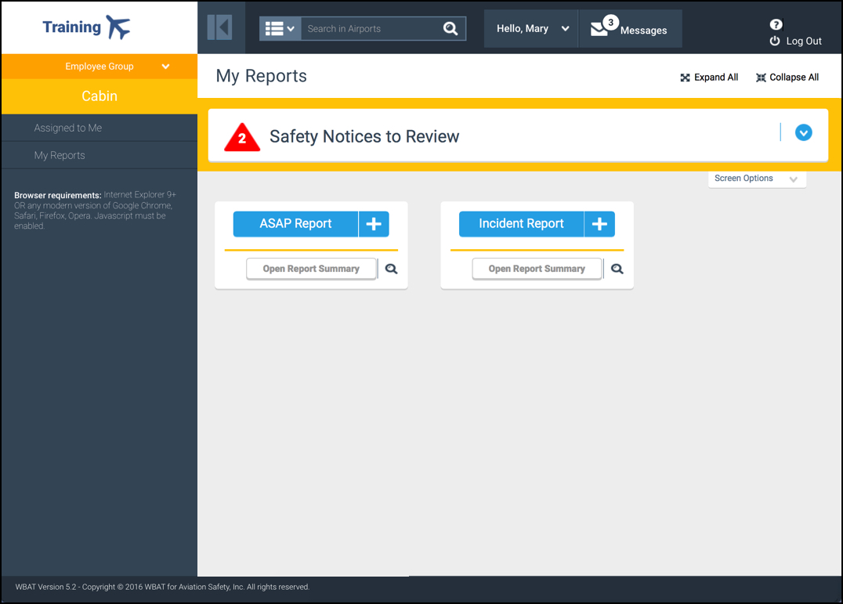
Figure 2–7. Sample My Reports Screen
When you expand the Report Summary (by selecting Open Report Summary), you always see Search Reports, which displays the Report Search screen, just as selecting the Search icon does. Other links only appear if one or more associated items exist, which is indicated by a number in parentheses that represents the number of available items. For example, in Figure 2–8, Finish an Incomplete Report (2) in the ASAP Section indicates there are two incomplete ASAP reports still to be finished (i.e., completed and submitted).
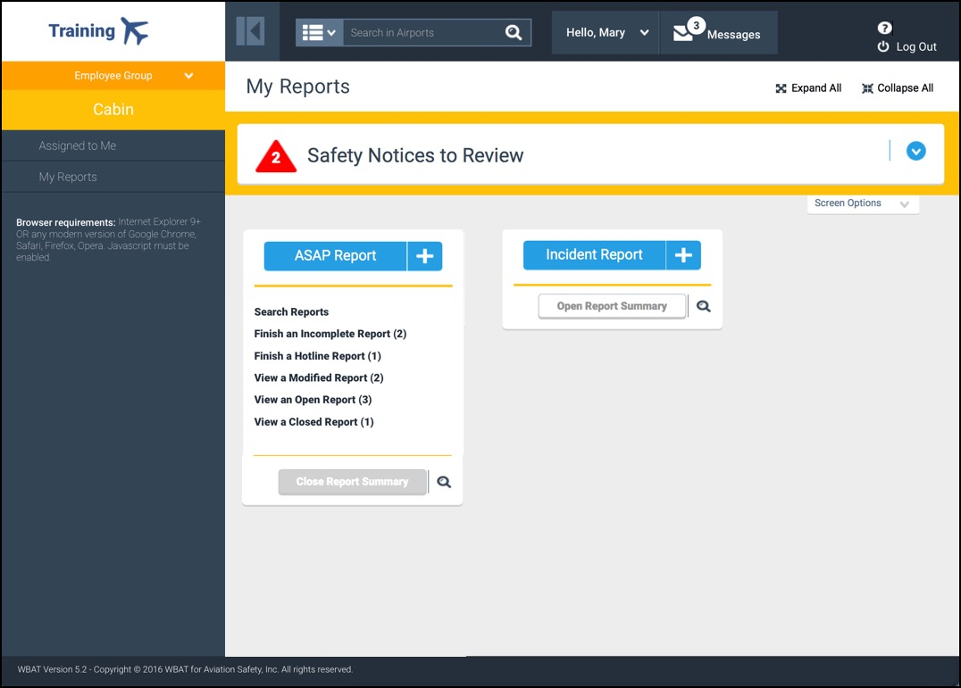
Figure 2–8. Sample My Reports Screen Showing Report Summary Links

Updating Your Profile
In order to submit a report, your profile’s contact information (e.g., job title, permanent address) must be included in the report for proper processing. When you first log into WBAT, you should update your contact information so you do not have to specify this information when you submit your report (see Updating Your Contact Information).

Accessing the Edit Contact Information Screen
In the Header Bar, hover the cursor over the User drop-down list to display available links, and then select Profile.
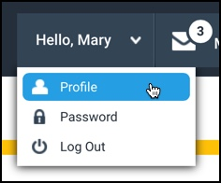
Figure 2–9. Profile Link

Editing Your Contact Information
In the Edit Contact Information screen that appears, update your information, and then click OK. The previous screen reappears.
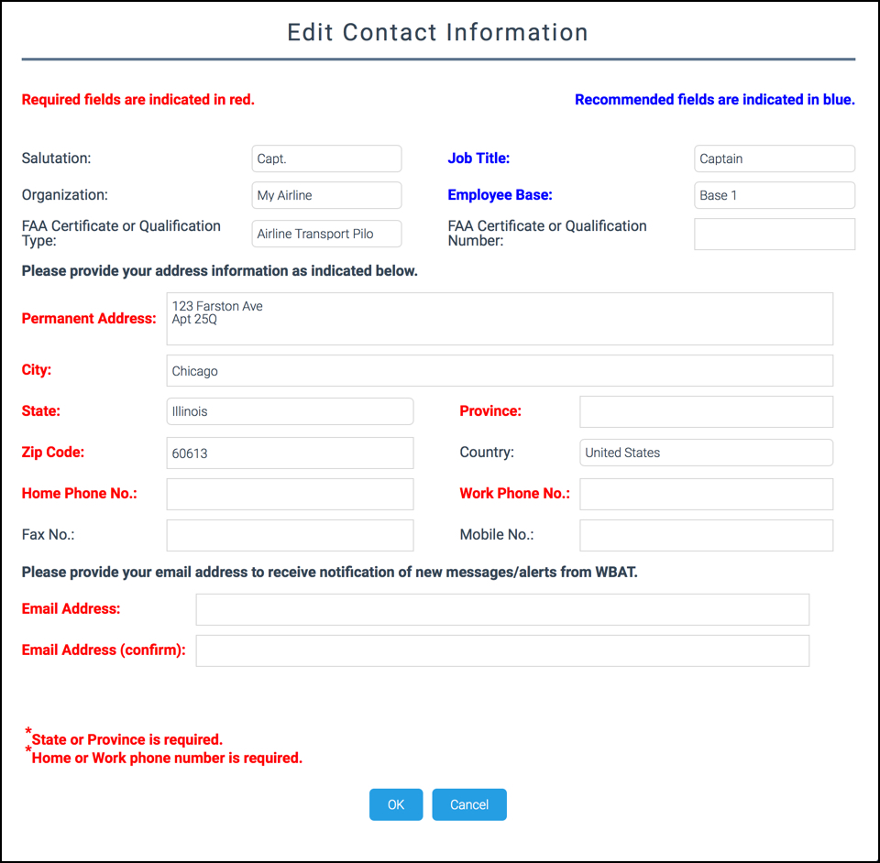
Figure 2–10. Edit Contact Information Screen

Changing Your Password

Accessing the Edit Password Screen
In the Header Bar, hover the cursor over the User drop-down list to display available links, and then select Password.
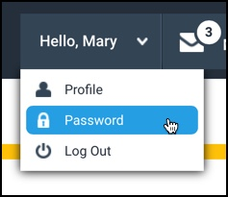
Figure 2–11. Password Link

Specifying a New Password
In the Edit Password screen that appears, specify your new password (at least six characters in length with at least one character and one number) in both text boxes, and then click OK. The previous screen reappears. The Cancel button returns you to the previous screen.
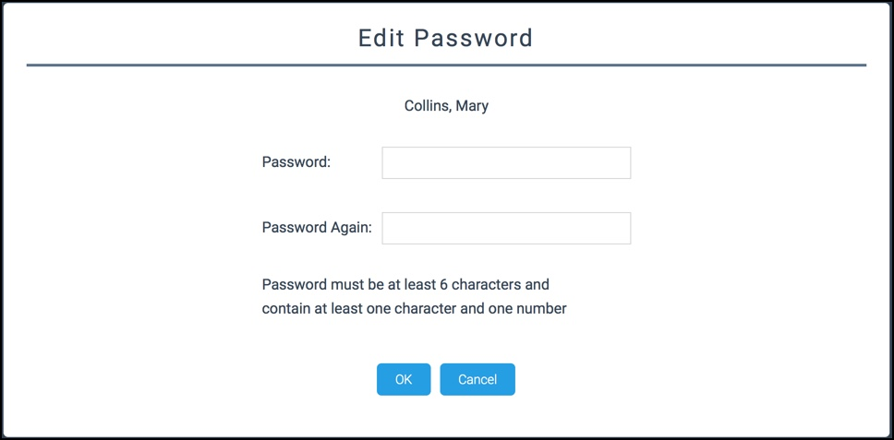
Figure 2–12. Edit Password Screen

Logging Out of WBAT
In the Header Bar, hover the cursor over the User drop-down list to display available links, and then select Log Out, or click the Log Out icon. You are logged out of WBAT.

Working with Reports
The My Reports screen contains the one or more report type Sections in the Workspace that let you submit new reports and manage your previously submitted reports for your designated employee group. You access the My Reports screen from the Side Bar Navigation link.

You also access the Assigned to Me screen from the Side Bar Navigation link, letting you view and manage reports that have been assigned to you by someone else.
The My Reports screen provides capabilities for the following:
- Adding a New Report. Options for periodically saving your report (see Saving and Continuing Your Report) and saving so you can complete and submit it at a later time (see Saving and Completing Your Report Later) are also described.
- Searching Your Reports.
- Finishing Your Incomplete Report.
- Finishing a Hotline Report.
- Viewing and Modifying Reports or Printing Submission Receipts and Reports.

Adding a New Report
In the appropriate report type section of the My Reports screen, select the Add Report icon.
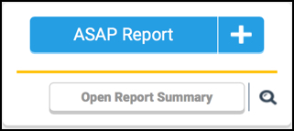
Select to add a new report
Figure 3–13. Add Report Icon
The New Report screen appears, indicating the employee group and report type in the report title.

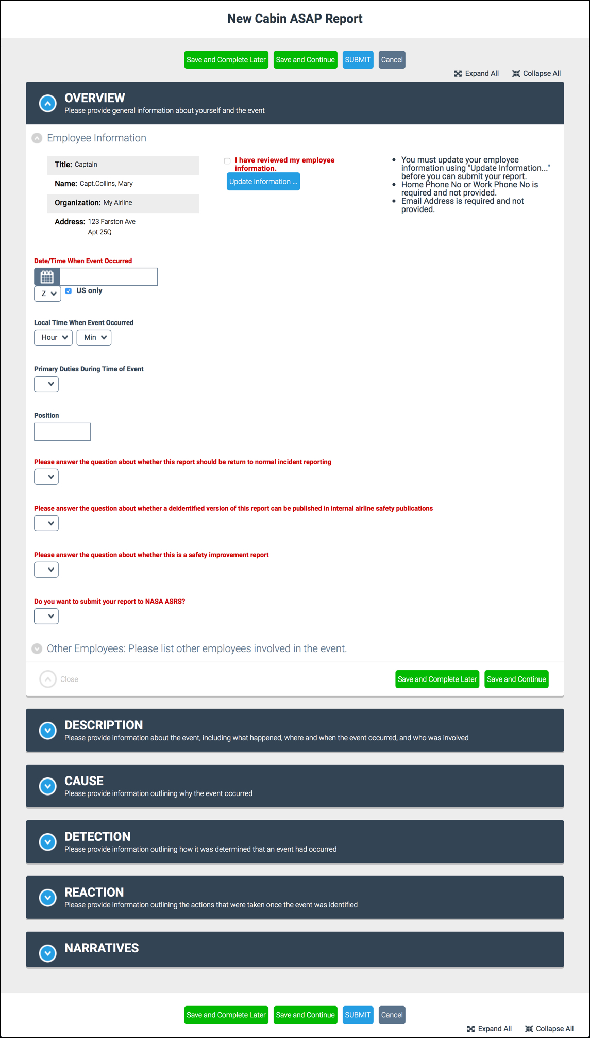
Figure 3–14. Sample New Report Screen

Understanding the New Report Screen Design
The New Report screen is divided into sections. Each section has a shaded title bar (that can be expanded and collapsed via the Expand and Collapse icons) and contains one or more screen elements (e.g., drop-down lists, checkboxes) to specify information about the issue. The sections that appear vary depending upon the report type and your company’s customization of the sections to include and their titles. For example, when submitting an ASAP report, the default sections are titled:
- Overview  - Description  - Cause | - Detection  - Reaction  - Narratives
Other report types may include all or only some of these sections (with these titles or customized ones). Specifying your information into the correct section will provide a more accurate report.

Understanding Tooltips
Most fields are self-explanatory; however, there are some screen elements that provide an expanded definition, or tooltip. To view the tooltip, hover the cursor over the screen element, and the definition will temporarily appear in a pop-up text box.
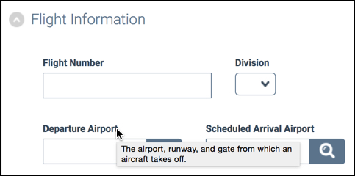
Hover over screen element to display tooltip
Figure 3–15. Tooltip

Understanding Report Narratives
Typically, when submitting a new report, text you supply in a “Narratives” section is associated with the report’s “Description” section once submitted. As long as a report is not closed, you are able to supply additional narratives to the original “Description” section, as well as other sections if an Update link appears in the section.
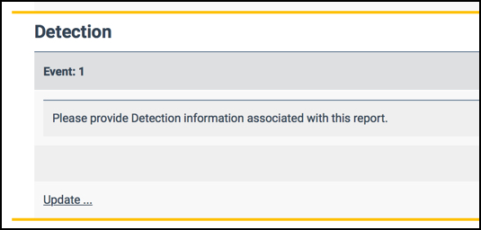
Select to add to the narrative
Figure 3–16. Update Link

Understanding NASA ASRS Data Sharing
If your company supports optional participation in ASRS data sharing, the Do you want to submit your report to NASA ASRS field appears in the upper right of the Overview section. To have WBAT forward your ASAP or incident report to ASRS, specify Yes in this field. An ASAP and/or incident report must be submitted within 10 days of the occurrence to comply with ASRS submission requirements. A transaction number that can be retrieved by your company’s WBAT administrator as a proof of transmission is generated in addition to the receipt WBAT displays upon report submission. (WBAT always assigns the report a transaction number even if the report was not submitted within the ASRS time requirements.) You should print the receipt for proof of your intent to transmit to ASRS in the event that NASA fails to receive the report (see Printing Your Submission Receipt).
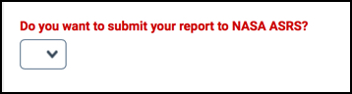
Figure 3–17. ASRS Data Sharing Field

Saving Your Report
The New Report screen includes save buttons at the top of the screen (as shown in Figure 3–18), as well as at bottom of the screen and of each report section. As you specify report details, periodically save your report.

To ensure you do not lose the information you have entered, recommended saving practices include:
- Before taking a short pause
- After specifying numerous issue details and adding narratives
- Prior to adding an attachment
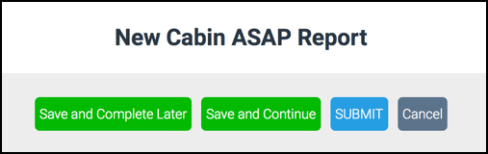
Figure 3–18. Save Buttons

Saving and Completing Your Report Later
To save your report and return to the My Reports screen, select Save and Complete Later (as shown in Figure 3–18). This save option allows you to start your report, specifying as much information as time allows, and then finish the report later, which lets you meet initial notification requirements. (If this is an ASAP report, MOU timeline requirements to complete and submit the report still apply.) The report’s status is Incomplete. You can resume completing the report by selecting Finish an Incomplete Report on the My Reports screen. (For more information, see Finishing Your Incomplete Report.)
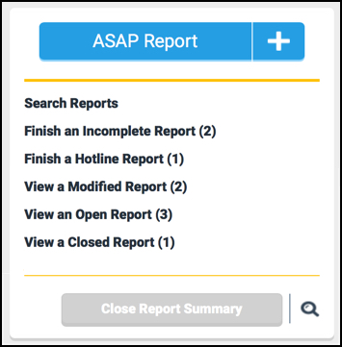
Select to finish an incomplete report
Figure 3–19. Finish an Incomplete Report Link

Saving and Continuing Your Report
To save (and continue displaying) your report, select Save and Continue (as shown in Figure 3–18) and then scroll back to where you left off to resume filling in your report or adding another attachment.

Submitting Your Report
When the report is complete, select SUBMIT (as shown in Figure 3–18), and then Yes at the Confirmation screen prompt. WBAT changes the report status to Open, incrementing by one the number of your open reports you can view from the My Reports screen.

Cancelling Your Report
When you want to leave your report without saving, select Cancel (as shown in Figure 3–18), and then Yes at the Confirmation screen prompt. (If you want to return to the report, select No at the prompt.) WBAT closes the report screen, and the My Reports screen appears.

Verifying Your Contact Information
In the Overview section of the New Report screen is the Employee Information subsection, listing your contact information. Required information that has not been specified is indicated, which can vary depending upon the report type and your employee group. You need to verify your contact information, either Confirming Your Contact Information is correct or Updating Your Contact Information to correct it.
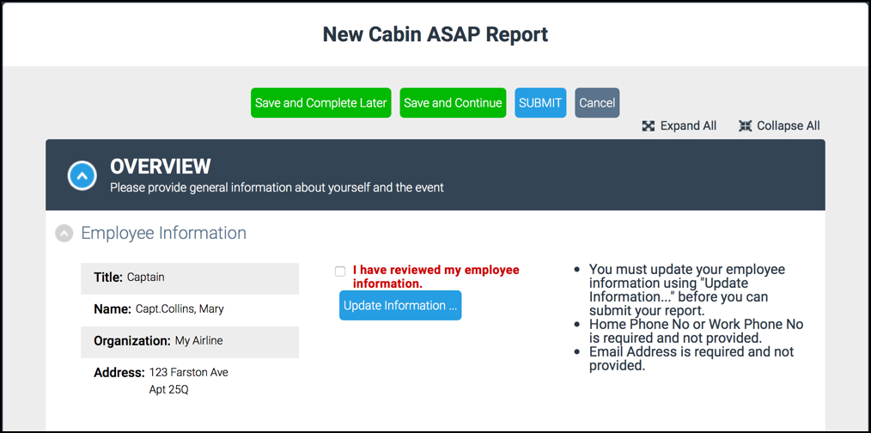
Must be checked to submit
Select to verify/update contact information
Identifies any unspecified required information
Figure 3–20. Employee Information Subsection of the New Report Screen

Confirming Your Contact Information
Verify your contact information, and if correct, check the I have reviewed my employee information checkbox. To continue, see Completing Your Report.

Updating Your Contact Information
Do the following:
- Select Update Information. The Edit Contact Information screen appears (see Figure 2–10).
- Specify the appropriate information and select OK to return to the New Report screen, displaying your updated contact information.
- When your contact information on the New Report screen is accurate and complete, check the I have reviewed my employee information checkbox.
- To continue, see Completing Your Report.

Completing Your Report
Continue filling out the report, ensuring the information you provide in your report is as accurate and complete as possible because once submitted, your original report and issue details are never altered and are permanently stored.

Adding an Attachment
If your company’s report allows you to add an attachment, select Choose File and then in the pop-up dialog box that appears, browse and select a file. The screen reappears, showing the selected file name to the right of Choose File. If you selected the wrong file, do not save the report; simply repeat the process of choosing a file. WBAT replaces the previous unsaved attachment with the newly specified attachment, showing the new file name to the right of Choose File.
After adding an attachment, you can also select Save and Complete Later. WBAT saves your report with the attachment and the My Reports screen appears. When you resume working on your incomplete report, “no file selected” appears to the right of Choose File. You can now add another attachment if you want (see Adding Multiple Attachments).
After you submit your report, when you access a modified, open, or closed report, the Overview Section of the submitted report screen includes a download link for each attachment.
You cannot delete or remove an attachment from a report once selected. Therefore, it is recommended that you save the report (see Saving and Continuing Your Report) prior to attaching a file. Otherwise, if you decide that no attachment is appropriate, you must cancel the report (see Cancelling Your Report), losing any unsaved information, and restart the report. You could also complete and submit the report with the attachment and then contact your company’s WBAT administrator, who is able to remove and/or update attachments on submitted reports.

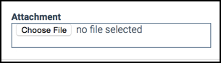
Figure 3–21. Choose File Button

Adding Multiple Attachments
To add multiple attachments, after choosing a file, select Save and Continue and then, after the screen refreshes, scroll down to the Narratives section to repeat the process of choosing a file and selecting Save and Continue until all files are attached. (After a report is saved, WBAT clears the file name of the previous attachment, displaying “no file selected” to the right of Choose File.)

Printing Your Submission Receipt
On the Receipt screen that appears, if you want your submission receipt, select the link to print a receipt for your records. The print dialog for your browser appears, letting you select a printer or save the receipt. Select OK to return to the My Reports screen.
If your company supports sending ASAP and/or incident reports to ASRS, print the receipt for proof of your intent to transmit to ASRS in the event that NASA fails to receive the report.

Creating a Fatigue Report from Your Submission Receipt
A link to create a new fatigue report appears if your company configured WBAT to support the user-selectable option to create a fatigue report prefilled with fatigue-related information and if the just-submitted report was an ASAP report with specific fatigue-related attributes (as defined by your company). After selecting the link, you can then review, make any desired changes, and submit this new fatigue report.
If your WBAT configuration supports the automatic generation of a fatigue report when the previous conditions apply, the receipt indicates the ID number of the associated fatigue report. You can only access this new fatigue report if you have access to fatigue reports.

Searching Your Reports

Displaying the Search Reports Screen
You can search for your incomplete, hotline, modified, open, and closed reports within a report type. In the appropriate report type Section, select the Search icon. The Report Search screen appears. To continue, see Specifying Search Criteria.

By selecting a column header link (e.g., “Flight Number”), you can change the single column by which the table is sorted. In this example, reports will be sorted, in ascending order, by the flight number associated with a report. Selecting the same column header link again will sort the reports in descending order.
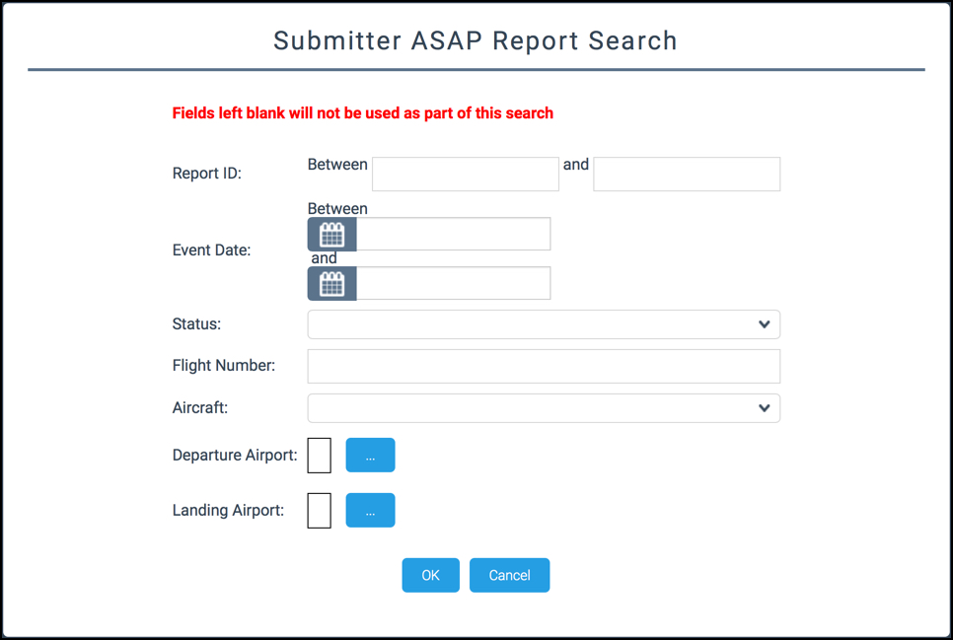
Figure 3–22. Report Search Screen

Accessing the Search Reports Screen from the Report Summary
You can also access the Search Reports screen from a link in the Report Summary. In the appropriate report type Section, select Open Report Summary.
Select to view a list of links for available report status actions
Figure 3–23. Open Report Summary Button
Then, select Search Reports.
Select to search for a report
Figure 3–24. Search Reports Link
The Report Search screen appears.

Specifying Search Criteria
Specify your search criteria (or leave all blank for all) and select OK. The Reports screen appears, listing reports that match your criteria.
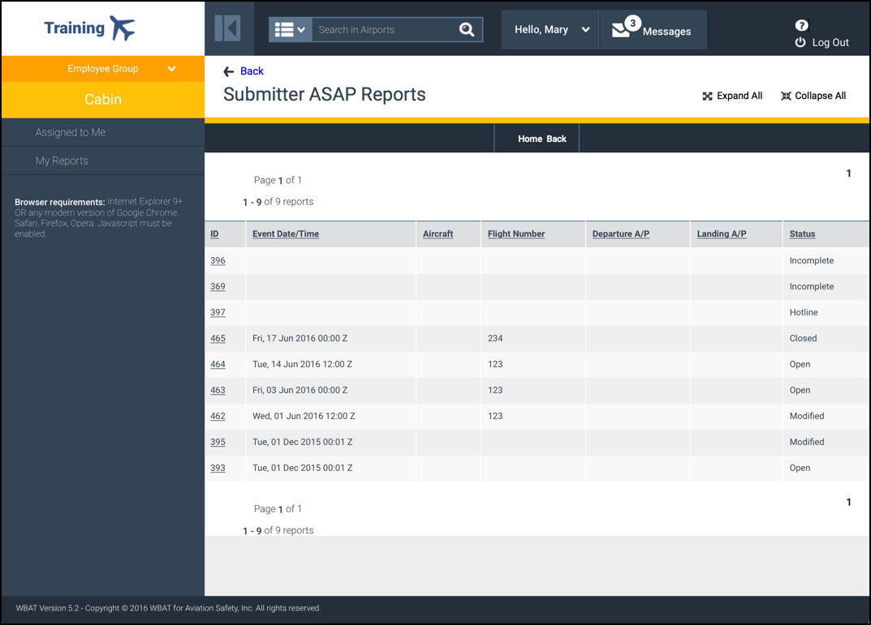
Figure 3–25. Reports Screen

Selecting a Report
Select a report ID link to display the report. If you selected an incomplete or hotline report, the Complete Report or Complete Hotline Report screen, respectively, appears. (Both of these screens offer functionality identical to the New Report screen, which appears when you select an Add Report icon.) Finish your incomplete or hotline report, beginning with Verifying Your Contact Information or Updating Your Contact Information, and then Completing Your Report (including Adding an Attachment and Adding Multiple Attachments, if applicable), Saving Your Report, and finally Submitting Your Report and Printing Your Submission Receipt.

You still have the option for Saving and Completing Your Report Later.
If you selected a modified, open, or closed report, the submitted report screen appears. To view and modify, i.e., add to the narratives of your submitted reports that have not been closed, see Modifying Your Modified or Open Report. To print any modified, open, and closed reports and their associated submission receipts, see Printing Your Modified, Open, or Closed Report.

Finishing Your Incomplete Report
Until you have submitted your report, you can save your report and complete it later by selecting Save and Complete Later on the screen, which sets the report’s status to Incomplete. In the appropriate report type Section, select Open Report Summary (as shown in Figure 3–23). Then, select Finish an Incomplete Report.
Only appears for you to select if an incomplete report exists
Figure 3–26. Finish an Incomplete Report Link
The Reports (Incomplete) screen appears, listing your incomplete reports.
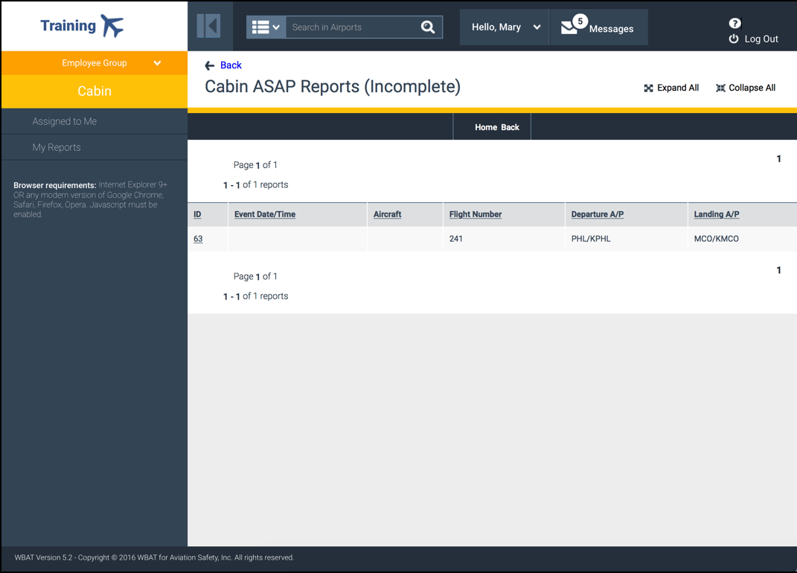
Figure 3–27. Reports (Incomplete) Screen

Selecting an Incomplete Report
Select a report ID link to display the report. The Complete Report screen appears, offering functionality identical to the New Report screen, which appears when you select an Add Report icon.

Finishing an Incomplete Report
Finish your incomplete report, beginning with Verifying Your Contact Information or Updating Your Contact Information, and then Completing Your Report (including Adding an Attachment and Adding Multiple Attachments, if applicable), Saving Your Report, and finally Submitting Your Report and Printing Your Submission Receipt.

You still have the option for Saving and Completing Your Report Later.

Finishing a Hotline Report
If you provided details of an issue to another user (e.g., phone call to a manager or a dedicated company hotline number), a hotline report can be submitted on your behalf, which you can complete when able. In the appropriate report type Section, select Open Report Summary (as shown in Figure 3–23). The term “hotline,” and its associated guidelines, defined by your company may differ from this description and procedure. Then, select Finish a Hotline Report.
Only appears for you to select if a hotline report exists
Figure 3–28. Finish a Hotline Report Link
The Reports (Hotline) screen appears, listing your hotline reports.
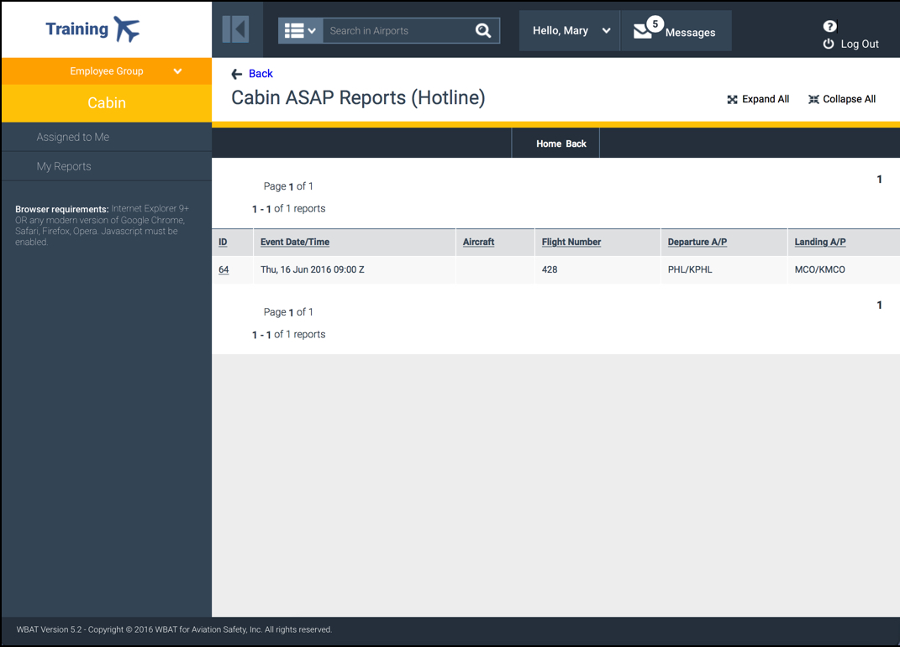
Figure 3–29. Reports (Hotline) Screen

Selecting a Hotline Report
Select a report ID link to display the report. The Complete Hotline Report screen appears, offering functionality identical to the New Report screen, which appears when you select an Add Report icon.

Finishing a Hotline Report
Finish your hotline report, beginning with Verifying Your Contact Information or Updating Your Contact Information, and then Completing Your Report (including Adding an Attachment and Adding Multiple Attachments, if applicable), Saving Your Report, and finally Submitting Your Report and Printing Your Submission Receipt.

You still have the option for Saving and Completing Your Report Later.

Viewing and Modifying Reports or Printing Submission Receipts and Reports
You can view and modify, i.e., add to the narratives of your submitted reports that have not been closed. In addition, you can print any modified, open, and closed reports and their associated submission receipts. To print an unsubmitted report, you must use your browser’s print functionality. You cannot edit or delete narrative information, only add to (i.e., augment) it. In addition, you cannot add, edit, or delete report attributes; however, your company’s WBAT administrator has this capability.
In the appropriate report type Section, select Open Report Summary (as shown in Figure 3–23). Then, do one of the following:
- Select View a Modified Report—For reports with a status of Modified, indicating you previously modified them.
- Select View an Open Report—For reports with a status of Open, indicating no modifications to the original submission.
- Select View a Closed Report—For reports with a status of Closed, indicating all report processing and resolution (e.g., de-identification, meeting review and disposition, corrective actions) have been completed and no further action is required.
Only appears for you to select if a report with a particular status exists
Figure 3–30. Finish a Hotline Report Link
The Reports (Modified), or Reports (Open), or Reports (Closed) screen appears, listing your modified, or open, or closed reports, respectively, depending upon the link you selected.
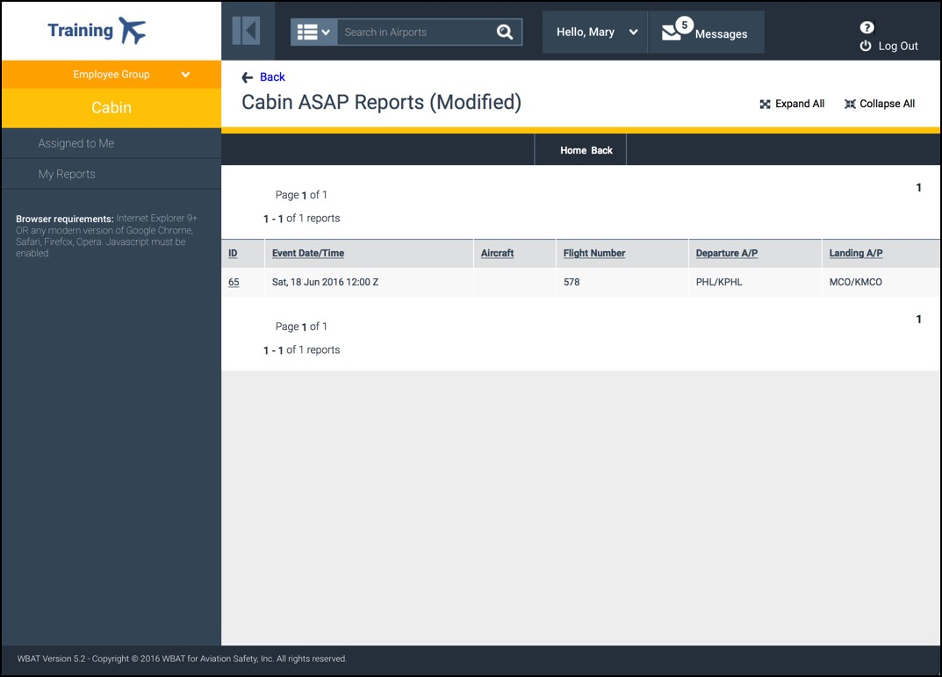
Figure 3–31. Reports (Modified) Screen

Selecting a Report to View
Select a report ID link to display the report. The submitted report screen appears, showing information about the selected report.
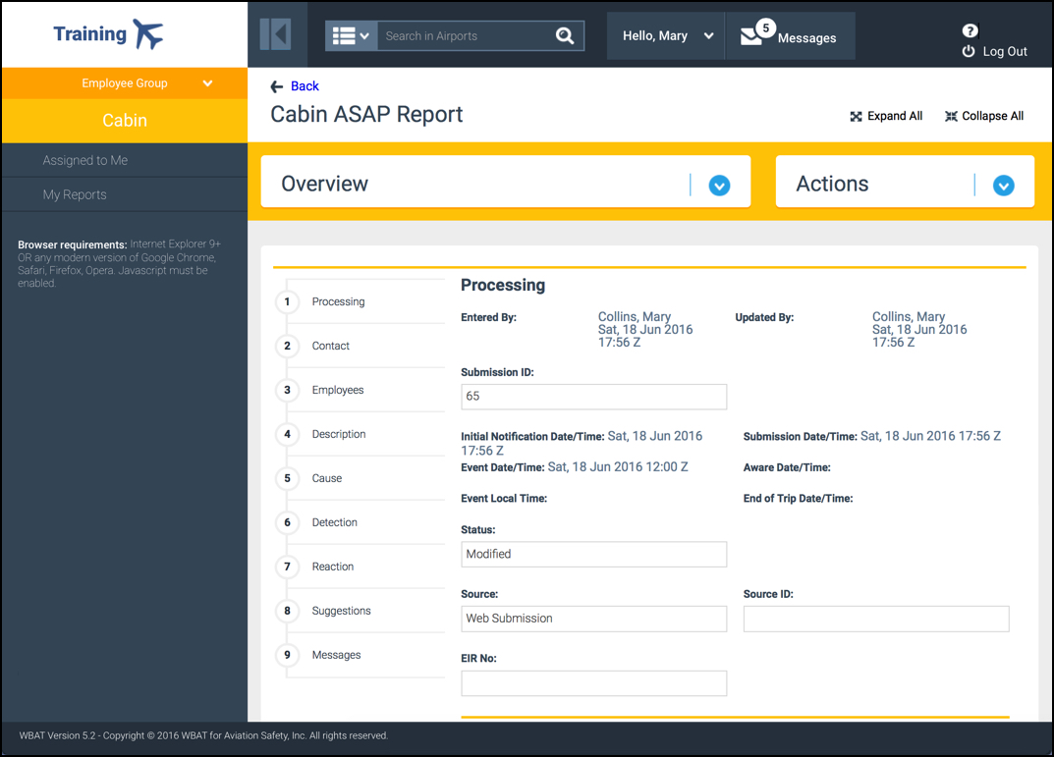
Figure 3–32. Submitted Report Screen

Understanding the Submitted Report Screen
The submitted report screen that appears when you access a modified, open, or closed report has the following screen elements:
- Overview—Located under the Title Bar, this Section provides general information about the report, such as:
  - Report status
  - Division
(Only includes information if your company uses this field on your report.)
  - Report’s form name
- Actions—Located under the Title Bar, this Section contains links for all available actions that you can perform when viewing the report. Actions vary depending upon your report. Submitters can:
  - Submit the report to ASRS
(Only appears for ASAP and incident reports if data sharing is supported.)
  - Print the receipt
  - Print the report
  - Send a Message
(See Using the Messaging System)
- Table of Contents—Located on the left side of the Workspace, the Table of Contents is a varying set of links (depending upon the report type) to each section of the report.
- Reports Sections—Located on the right side of the Workspace, the various report sections correspond to the links in the Table of Contents.

Modifying Your Modified or Open Report
- Use the links in the Table of Contents or scroll to the section of the report for which you want to add narrative text.
- Select Update, located at the bottom left of the section box.
Select to add to the narrative
Figure 3–33. Update Link
- In the Augment Narrative screen that appears, specify the appropriate additional narrative and select OK. The Report screen appears with the newly added narrative text, which is date and time stamped to show when it was added.

Submitting Your ASAP or Incident Report to ASRS
From the Processing level of the Actions Section, select Submit report to ASRS, and then Yes at the Confirmation screen prompt. The submitted report screen appears, without Submit report to ASRS in the Actions Section.

Printing Your Modified, Open, or Closed Report
From the Print level of the Actions Section, select one of the following:
- Print report. A screen appears, displaying an HTML version of the report that you can send to your printer or save.
- Print report as text. A screen appears, displaying a text version of the report that you can send to your printer or save.

Understanding WBAT Safety Notices
WBAT’s Safety Notices Section appears in the Action Bar, letting your company post short informational messages to the primary Workspace screen of all users within a specific employee group. For example, suppose a new runway procedure is in effect at a particular airport. Your company can create a safety notice to alert all flight crews flying into that airport. To ensure users are aware of new safety notices, WBAT supports the option of sending of a tickler email message to users as part of the safety notice creation process.
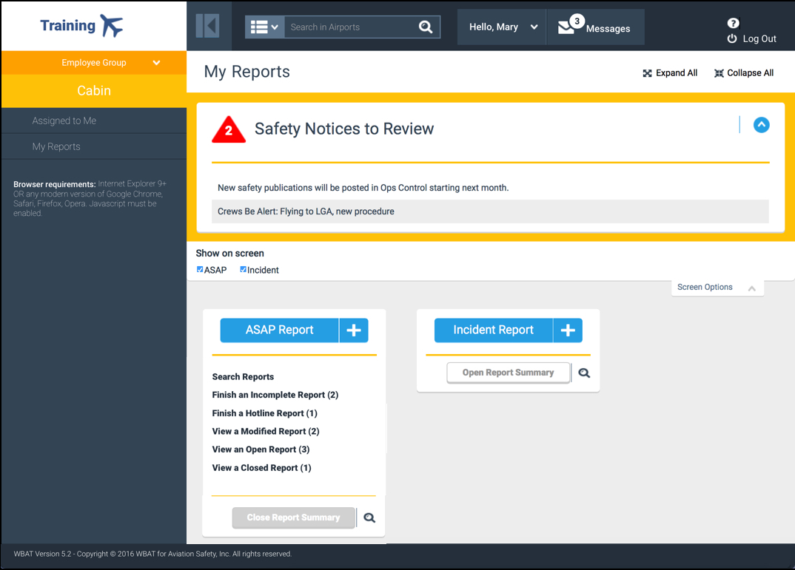
Figure 4–34. WBAT Safety Notice Section

Performing a System Search
The system search function allows you to view information based on a specified search term within such system parameters as (varying depending upon your employee group and/or privilege):
- Aircraft  - Airports  - Events/summaries  - Navigational aids | - Procedures  - Reports  - Sent/received messages  - Waypoints
Do the following:
- In the Header Bar, specify the full or partial search term (e.g., a three-letter airport code) in the Category text box (or leave blank for all).
Select a search parameter
Enter your search term
Figure 5–35. Category Drop-down List and Text Box
- Select a search parameter in the Category drop-down list (e.g., Airports).
- Select Category Search icon to the right of the text box.
- On the Search Results screen that appears, select the link of the desired match.

You can change the sort order by selecting the column header link.

Using the Messaging System

Sending Messages
Do the following:
- In the Header Bar, hover the cursor over the Messages drop-down list and select Send a Message.
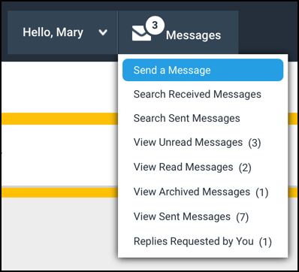
Select to create and send a message
Figure 6–36. Send a Message Link
- In the New Message screen that appears, specify the recipient(s). (For details, see Specifying Message Recipients, which follows.)
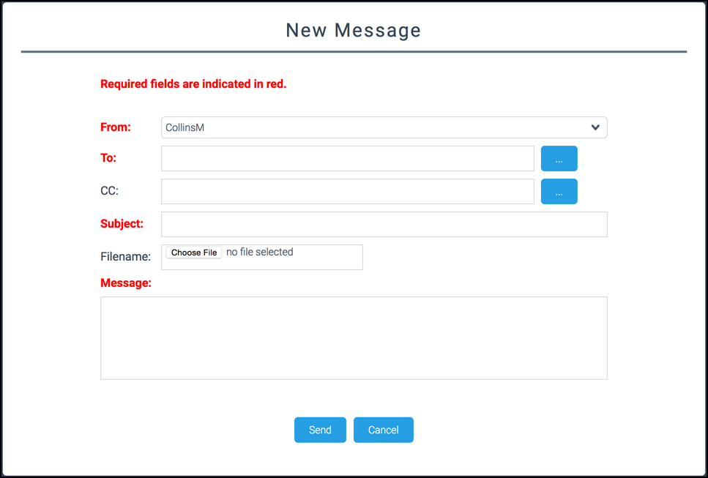
Figure 6–37. New Message Screen
- Fill in the Subject and Message, and if appropriate, attach a single file.
- Select Send.

Specifying Message Recipients
Do the following:
- Select the More icon at the end of the To field.
- In the Employee/User Group Search screen that appears, do one of the following:
  - Perform an employee search—In the text box, specify the employee search information and select Search. In the list of matching employees that appears, select the appropriate employee and then Select.
  - Select an employee group—From the drop-down list, select an employee group and select Search.
The New Message screen appears with the specified recipient in the To field.
- Repeat the previous step as needed to specify additional recipients.

Attaching a Report to a Message
Do the following:
- From the My Reports screen, open the desired report. (For details, see Viewing and Modifying Reports or Printing Submission Receipts and Reports.)
- With the Report screen displaying, from the Actions Section, select Messages and then Send a Message. This report will be attached to your message.

The report sent to the recipient will NOT be de-identified.
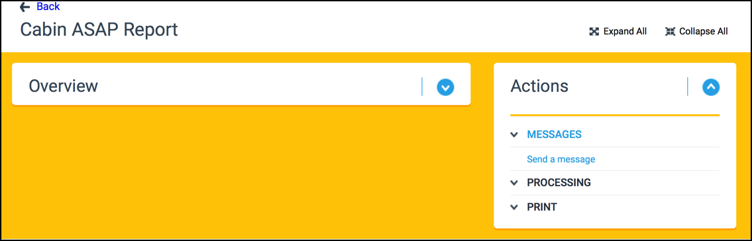
Select this link
Figure 6–38. Sending a Message from a Report
- In the New Message screen that appears, complete and send the message as detailed in Sending Messages.

Searching for a Message
Do the following:
- In the Header Bar, hover the cursor over the Messages drop-down list and select the appropriate link:
  - Search Received Messages
  - Search Sent Messages
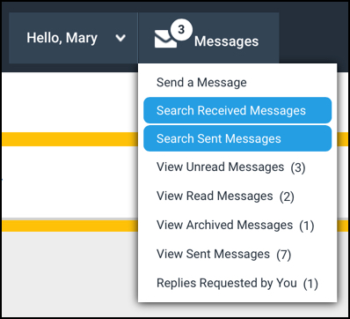
Select either link
Figure 6–39. Search Received Messages and Search Sent Messages Links
- On the Search Received (or Sent) Messages screen that appears, specify the criteria that you wish to search on (e.g., message date range) and select OK.
- On the Received (or Sent) Messages screen that appears, listing received (or sent) messages that match your criteria, select a Name link to display the message.

You can change the sort order by selecting the column header link.

Viewing Messages
Do the following:
- In the Header Bar, hover the cursor over the Messages drop-down list and select the appropriate link:
  - View Unread Messages
  - View Read Messages
  - View Archived Messages
  - View Sent Messages
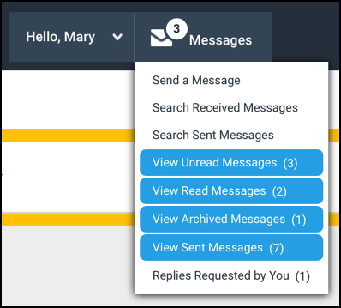
Select a link
Figure 6–40. Links for Viewing Messages of Various Statuses
- On the Messages screen that appears, listing applicable messages, select a Name link to display the message.

Replying to Message Requests
The Replies Requested by You link indicates when someone has sent you a message that requires your response (i.e., the sender specified a response date in the message).
Do the following:
- In the Header Bar, hover the cursor over the Messages drop-down list and select Replies Requested by You.
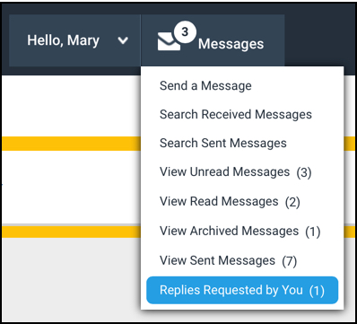
Select to reply to a message
Figure 6–41. Replies Requested by You Link
- From the Messages (Replies Requested by You) screen that appears, select a Name link to display the message.
- To reply to the message, on the Inbox Message window, select Reply in the Actions box. You can also “reply all” or forward the message.
- Complete the message (e.g., answer the sender’s questions, attach a file) and then select Send.

Once you have replied, the number of “Replies Requested by You” is reduced by one.

- Key Terms
Table A–1. Key Terms
Term | Definition
Aviation Safety Reporting System (ASRS) | Developed based on AC 00-46E, NASA ASRS is a voluntary system for reporting actual or potential discrepancies and deficiencies involving the safety of aviation operations.
Closed Report | A report for which all processing and resolution (e.g., de-identification, meeting review and disposition, corrective actions) have been completed and no further action is required.
Company | Refers to all carrier types, airline operators, flights schools, etc.
Corrective Action | Actions that can be assigned to any WBAT user or a specific department in a company with the intent of improving, fixing, and eliminating an identified safety issue, e.g., additional user training, updating a user manual. The specified action and all related details are archived in WBAT.
De-identify | The removal of personal information from a report.
Employee Group | WBAT supports a variety of report types to accommodate safety reporting for all company employees. Each report type can be tailored to collect information specific to the different employee groups.
Hotline Report | If you provided details of an issue to another user (e.g., phone call to a manager or a dedicated company hotline number), a hotline report can be submitted on your behalf, which you can complete when able.  The term “hotline,” and its associated guidelines, defined by your company may differ from this description and procedure.
HTML Version | A display of information that uses the standard markup language (i.e., HyperText Markup Language [HTML]) to create webpages that can include various text formatting features (e.g., fonts, colors).
Incomplete Report | A report that has been started but not completed (i.e., submitted). WBAT allows for an unlimited number of edits to a report before being finally submitted, at which point, the original report is referred to as a submission.  An open report, on the other hand, can only be modified by the Submitter to add to the existing narratives. Submitters cannot include any additional attributes, nor remove anything previously entered.
Issue | In WBAT, an issue is a safety-related instance that occurred or may occur. With its various report types, WBAT accommodates a range of different issue types, allowing companies to capture information specific to each issue type and then process and review the information for each particular issue instance in order to identify appropriate corrective actions to mitigate risk of similar issues in the future.
Modified Report | A report that the Submitter has changed from the original form, or submission, to add to the existing narratives. Any previously entered details (e.g., attributes) cannot be removed/edited.
Open Report | A report that has been submitted but the processing, review, and resolution have yet to be completed.
Privilege | The specific set of permissions assigned to you (by your company Administrator) to allow access to certain WBAT tasks and functions based on your role, authorized report types, and designated employee group(s).
Report | Refers to the processed record that describes a particular safety-related issue documented via an online form. Once submitted, the report goes through several stages of processing, where the original information (i.e., the submission) is evaluated, analyzed, de-identified (i.e., removal of personal information), and verified/modified before being reviewed and, ultimately, resolved, possibly through corrective actions if warranted.
Safety Notice | WBAT’s safety notices feature allows a company to post a short informational message to the primary Workspace screen of all users within a specific employee group. For example, suppose a new runway procedure is in effect at a particular airport. A company can create a safety notice to alert all flight crews flying into that airport. To ensure users are aware of new safety notices, WBAT supports the option of sending of a tickler email message to users as part of the safety notice creation process.
Scoreboard | The Scoreboard is an optional feature that allows Submitters to view de-identified, closed reports. This includes their reports, as well as those from other Submitters.
Submission | When a user completes and submits an online form in a WBAT report type, the original form is referred to as a submission. The submission serves as a permanent record of a wide range of details about a particular safety issue, incident, or concern observed, noticed, or discovered. The submission is never altered and is stored in its original state.
Ticker Email | An automated email that advises the recipient of specific information.
Text Version | A display of information in basic plain-text (i.e., American Standard Code for Information Interchange [ASCII]) format.
WBAT Administrator | Your company’s WBAT administrator is the user responsible for configuring, implementing, and maintaining your company’s WBAT system. This user has access to all areas of WBAT and information contained within. This user troubleshoots and resolves system problems.

